

**CEE 598 – Traffic Simulation Modelling and Applications**

**Instructor: Professor Xuesong Zhou**

**Assignment: Homework #5**

**Done by: Mohamed Jatit**

***Question #1:***

***Part A:***

Link Information:

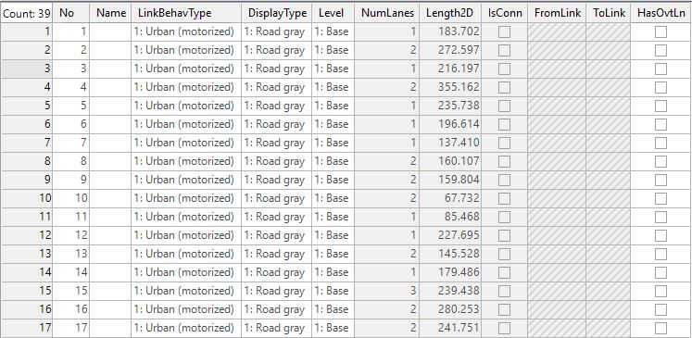

Connector Information:

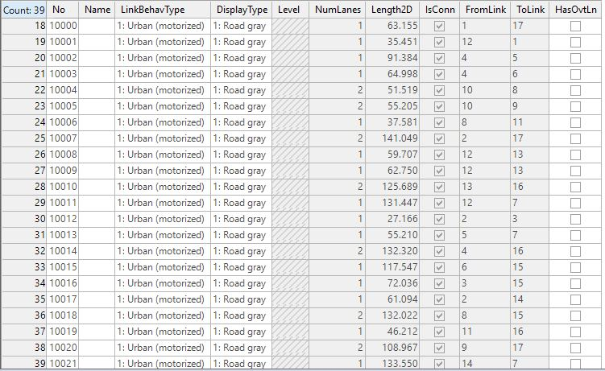

Vehicle Input Information:

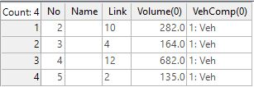

***Part B:***

Vehicle Travel Time Results:

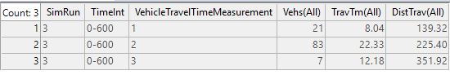

***Question #2:***

GM-3 car following model:

Integrating with respect to t yields:

Substitute µ for and for , then:

Substitute for :

*When*  and :

Finally,

***Question #3:***

Little’s law:

Take as number of vehicles on the roads and as average travel time

Assuming the length of the road is :

Dividing both sides of the equation by L:

where denotes the density

where denotes the arrival rate of the vehicles

where denotes the average speed of all vehicles

Finally,